TASK 1 SOLUTIONS:
I used a photo resistor in series with a normal resistance and then ran a test ckt in which I measured the potential drop a/c the normal resistor as I went from min possible value of light to maximum possible value of light(the values were 6 and 679). Then I used basic if else statements to turn the led on after a certain threshold.
Ckt:
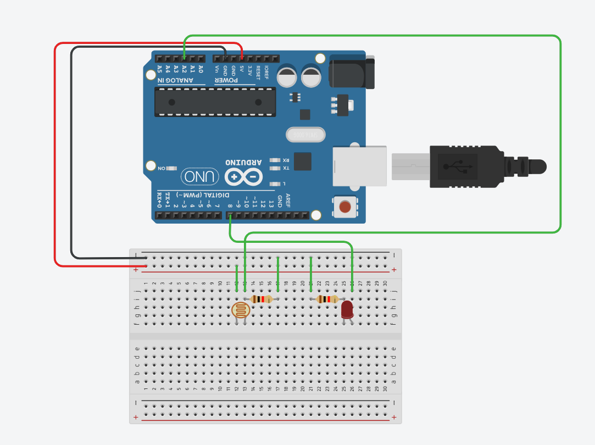
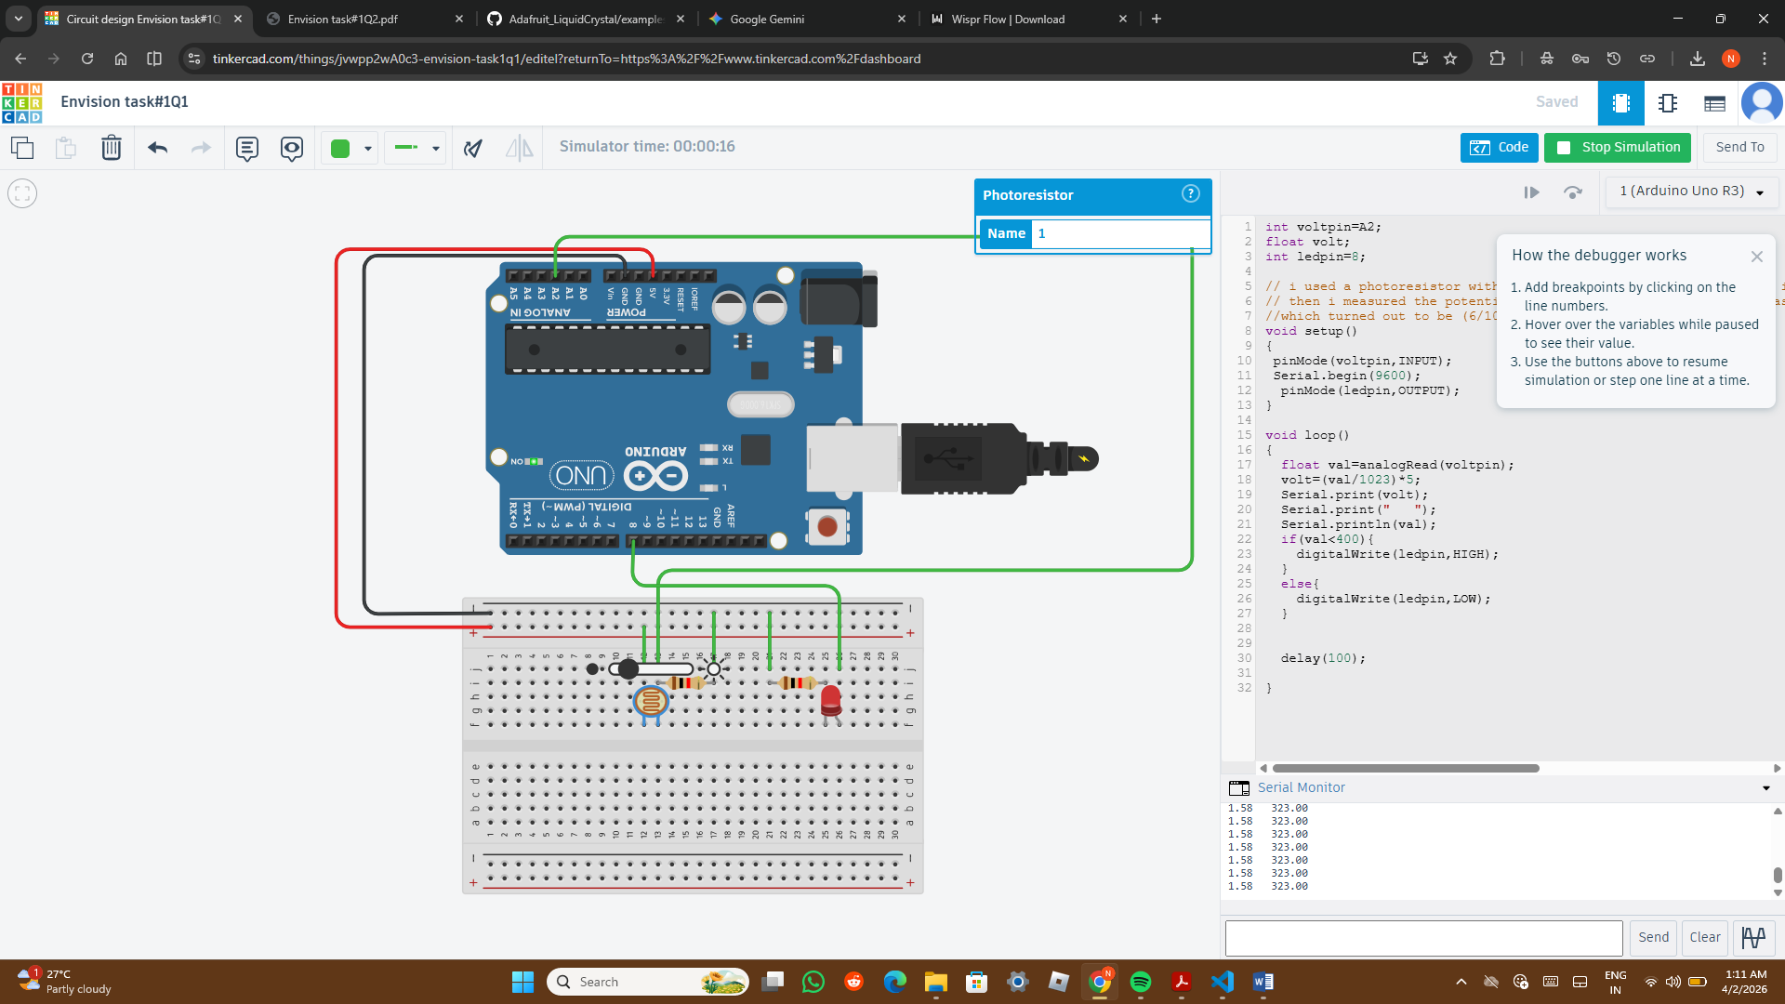
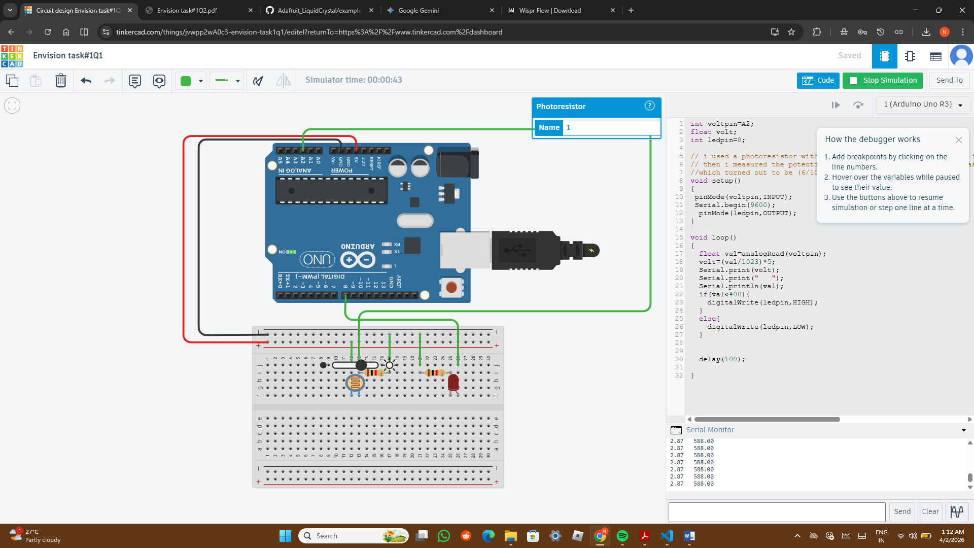
int voltpin=A2;
float volt;
int ledpin=8;
void setup()
{
pinMode(voltpin,INPUT);
Serial.begin(9600);
pinMode(ledpin,OUTPUT);
}
void loop()
{
float val=analogRead(voltpin);
volt=(val/1023)*5;
Serial.print(volt);
Serial.print(" ");
Serial.println(val);
if(val<400){
digitalWrite(ledpin,HIGH);
}
else{
digitalWrite(ledpin,LOW);
}
delay(100);
}
https://www.tinkercad.com/things/jvwpp2wA0c3-envision-task1q1

TASK 2 SOLUTION:
I used the adafruit github repo for the functions.
#include <Adafruit_LiquidCrystal.h>
Adafruit_LiquidCrystal lcd(0);
int pin1=9;
int pin2=7;
int pin3=5;
int pin4=3;
int num1,num2;

void setup() {
Serial.begin(9600);
lcd.begin(16, 2);
lcd.setBacklight(HIGH);
lcd.print("hello, world!");
delay(2000);
lcd.clear();

pinMode(pin1, OUTPUT);
pinMode(pin2, OUTPUT);
pinMode(pin3, OUTPUT);
pinMode(pin4, OUTPUT);

}

void loop() {
Serial.println("Enter your number1: ");
while(Serial.available()==0){
}
num1=Serial.parseInt();
Serial.println(num1);
Serial.println("Enter your number2: ");
while(Serial.available()==0){
}
num2=Serial.parseInt();
Serial.println(num2);
int stat1,stat2,stat3,stat4;
int num3=num1+num2;
if(num3>15){
lcd.print("OVERFLOW!!");
delay(4000);
}
else{
stat4=num3/8;
int rem1=num3%8;
stat3=rem1/4;
int rem2=rem1%4;
stat2=rem2/2;
int rem3=rem2%2;
stat1=rem3;
if(stat1==1){
digitalWrite(pin1,HIGH);
}
else{
digitalWrite(pin1,LOW);
}
if(stat2==1){
digitalWrite(pin2,HIGH);
}
else{
digitalWrite(pin2,LOW);
}
if(stat3==1){
digitalWrite(pin3,HIGH);
}
else{
digitalWrite(pin3,LOW);
}
if(stat4==1){
digitalWrite(pin4,HIGH);
}
else{
digitalWrite(pin4,LOW);
}
lcd.print("SUM IS :");
lcd.setCursor(0,1);
lcd.print(num3);
delay(5000);
lcd.clear();

}
lcd.clear();
digitalWrite(pin1,LOW);
digitalWrite(pin2,LOW);
digitalWrite(pin3,LOW);
digitalWrite(pin4,LOW);

}
I first initialize the lcd display by setting the backlight to HIGH, and then I display hello world to check if it works(not necessary). And then initialize the pin modes. In the loop function, I take the input from the user with the help of serial monitor using the serial.parseInt function. The while(serial.available==0) statement makes the serial monitor wait till the user inputs his number t=by pressing enter. I take two inputs, store them in two variabes, and then add them to store in a third variable. Then I check if its more than 15: if yes, then I display overflow message, wait for 4 secs, and then repeat the process…if no, then I divide the num3 by 8, as its an division of integers,the output will be integer( and it can be 0 or 1(0 if number is less than 8, 1 if sum is greater than 8), then store the remainder in another variable, and then repeat the process for 4 and 2. Then I store the results in 4 vribles which will then determine the state of pin(HIGH is 1, LOW if 0)(I used basic if/else for this part of program). Then once the output is displayed, I clear the lcd, and the loop function begins again.
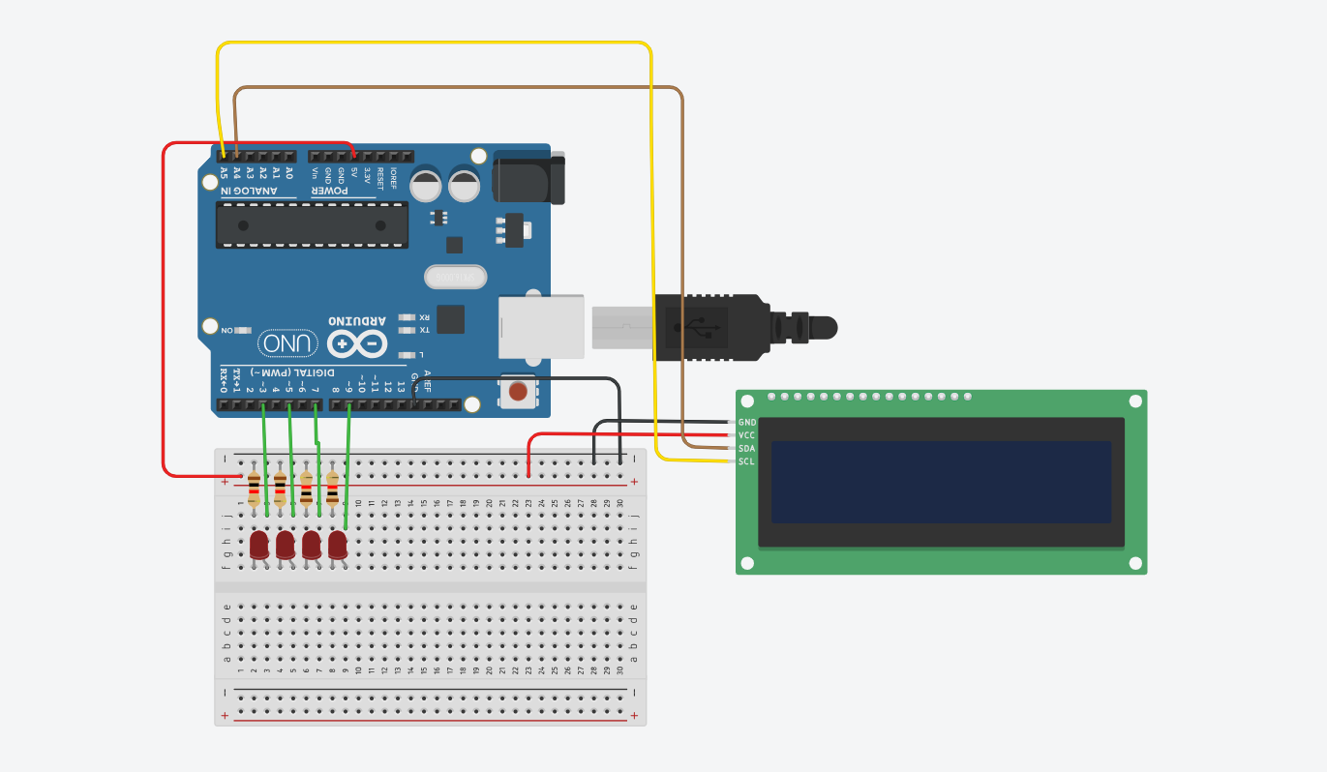
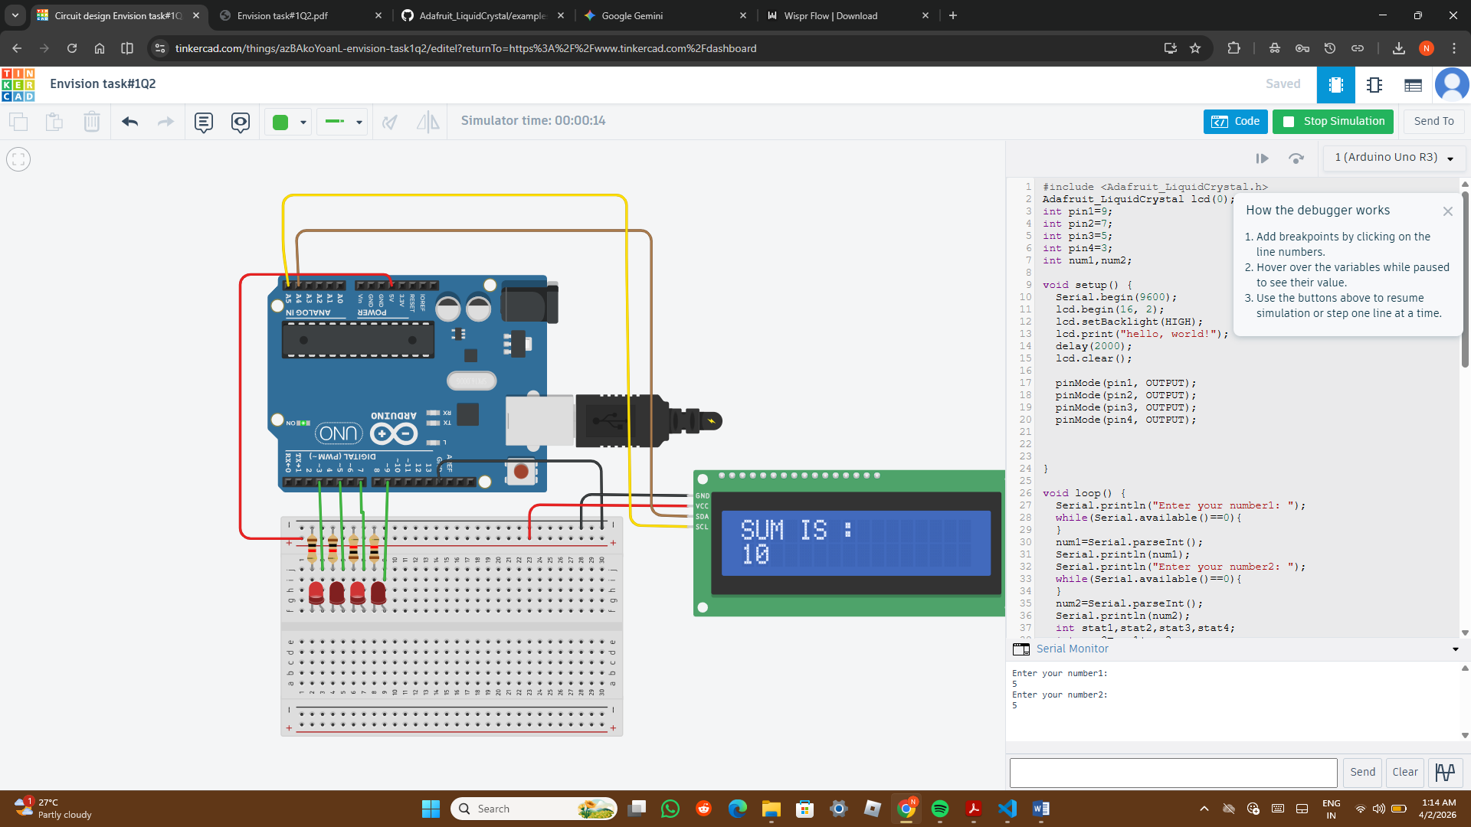 https://www.tinkercad.com/things/jvwpp2wA0c3-envision-task1q1